TRANSISTOR

A Transistor is an electronic device composed of layers of a semiconductor material which regulates current or voltage flow and acts as a switch or gate for electronic circuit.
Applications:

- Switching
- Amplification
- Oscillating Circuits
- Sensors
SWITCHING:

- The modern computer is a digital and electronic device.
- Runs on flow of electrons - movement of electrons from outer valence shells on atoms
- Requires force/energy to pull an electron out of a shell - Electro-motive force (EMF) - Voltage
- How tightly the electrons are held determines how much voltage is needed and is quantified as resistance
- Number of Electrons flowing is quantified as Amperes

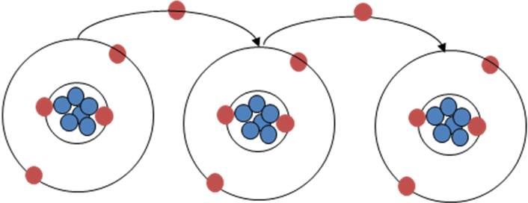

- Computers are electronic switching devices
- Voltage source (battery)
- Meter to detect voltage differential
- Computers are constructed from transistors
- Transistor are used as on-off switches (0-off, 1-on), hence binary

